My Thoughts about game theory

Game theory is a type of mathematics that not only can be used in individuals,but also can be used in collectives ,society, international community, even though they may not understand.Take individual as an example,even every life in our earth born equal,they will according to organic evolution turn into different species,and it has different features,which mean that they have different resources.Different resources decide they have different results.

Measure what is game, game is players use actions to gain maximize interests.

Game theory is a way to gain more interests for no matter individuals or groups,countries.

Game players have to bigger than 1,but in realistic world,one person play with him or her whatever self is acceptable,in sum language is player{x|x∈n1}

Sum game= {players,producer,rule,resource}

Players use resources in their game,at the same time they can’t break the rules,if they break the rules,producer will give them punishment.

Producer is this game’s rules producer,they are executor of the rules.usually it will give the strongest and win best player.

Rules follow Nash equilibrium .

Self interested agents and utility theory

1. only that the agent has its own description of states of the world that it likes, and acts based on this description utility function.
2. Quantifies degree of preference across alternatives.
3. Explain the impact of uncertainty
4. Decision theoretical rationality act to maximize expected utility
5. Self interest don’t bad in all aspects.

Normal form:action set for player I,Ai

a=(a1,a2,a3, …,an) ∈A,A1,A2,A3, …,An is action profile.

Utility function or payoff function for players,u=(u1,u2, …,un) is a profile of utility functions. Even though something strictly follow a simple rule,pain more gain more,but in some uncertain situations it has changes. It sounds like schrodinger’s cat,sometimes we can only know the results after opening the box,we don’t know what results will get.

Collective interests will create a new symbol but I can’t figure out so just collective interests is ok.

Take classic prisoners dilemma as an example

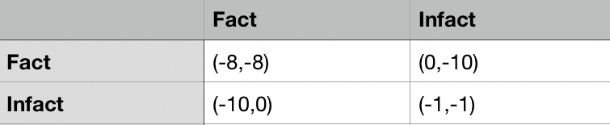

For starters,a={a1,a2,a3,…,an}∈Ai

Ai=A1\*A2\*…\*An. A∈N\*

u={u1,…,un}

u=a1x\*a2y\*Aiw

It’s worth noting that due to providing the fair of game,people usually have same instruction set.(A1=A2=…Ai)But in real world,it’s unrealistic to have absolutely fair equipment,then League of Legend do a really good job that five people in a group and take different career ,at the same time enemy have same groups(I didn’t mean that it’s the founder of this strategy, I just say this strategy is good)in ancient times,clan usually use strongest soldiers and leave weak old players alone.Then we review.In fact,many species when very young time knows how to cooperate,it’s in our blood.But many people spent a long time to find out individual.

The number of players:N

Actions:Ai(a1,a2,a3,…,ai)

Payoffs:ui

u1(a)+u2(a)=c

There’s many types of strategies exist,overall it can divide into weak strategy,medium strategy and strong strategy.

In others side, it can divide into pure strategy,mixed strategy and dominant strategy.

Modern society and game strongly follow below rules.

Natural selection:Natural selection is the process through which populations of living organisms adapt and change. Individuals in a population are naturally variable, meaning that they are all different in some ways. This variation means that some individuals have traits better suited to the environment than others. Individuals with adaptive traits—traits that give them some advantage—are more likely to survive and reproduce. These individuals then pass the adaptive traits on to their offspring. Over time, these advantageous traits become more common in the population. Through this process of natural selection, favorable traits are transmitted through generations.

Copy in https://education.nationalgeographic.org/resource/natural-selection/

It’s worth noting that it doesn’t choose strongest individuals or smartest individuals,it chooses most suitable equipment individuals .

The principle of abundance,in Chinese language,When the forest is big, there are all kinds of birds.

People are born equal We hold these truths to be self-evident, that all men are created equal, that they are endowed by their Creator with certain unalienable rights, that they are among these are life, liberty and the pursuit of happiness.

For the sake of providing the fairness of game,players usually same sum,and players cannot control others choice.

sometimes we outcome O is at least as good for every agent as another outcome O’,and there’s some agent who strictly prefer o to o’.

Definition (Pareto optimality )

An outcome o\* is pareto-optimal if there is no other outcome that pareto-dominates it.

Previously prisoners dilemma, we use excel to find out the answer,but it can not figure out when the number of players bigger than three.

Draw a picture

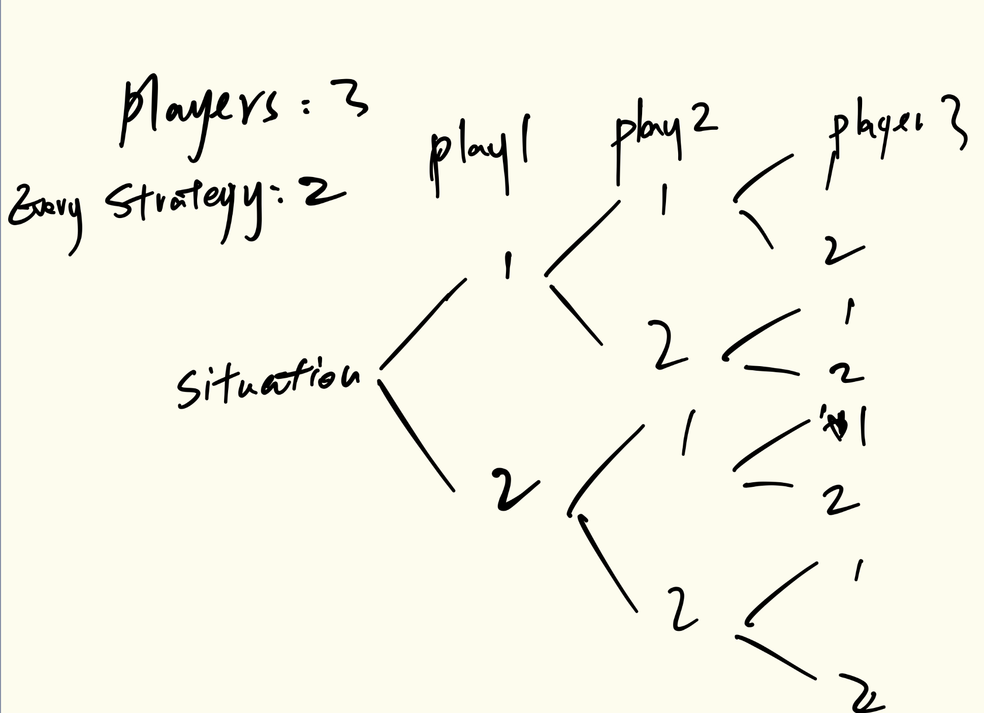

Pn=1-P1-…Pn-1

Randomize doesn’t win the contest，when we choose an action,but if someone is super stupid,randomize is go better than choose wisest action.

People are strongly and highly find Nash Equilibrium,then we need to find players aim.